**PRESS CONTACT:**

**amazonpublishing-pr@amazon.com**

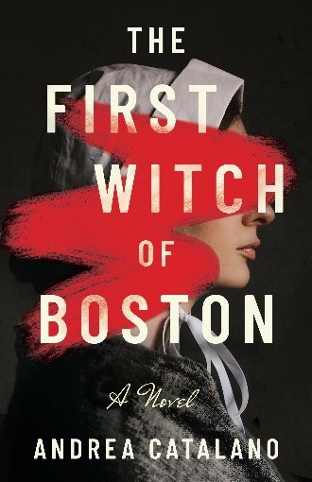 **The First Witch of Boston**

**By Andrea Catalano | September 1, 2025**

**A gripping and intimate novel based on the true story of Margaret Jones, the first woman to be found guilty of witchcraft in seventeenth-century Massachusetts.**

Massachusetts Bay Colony, 1646. Thomas and Margaret Jones arrive from England to build a life in the New World. Though of differing temperaments, cautious Thomas and fiery Margaret, a healer, are bound by a love that has lasted decades. With a child on the way, their new beginning promises only blessings.

But in this austere Puritan community, comely faces hide malicious intent. Wrong moves or words are met with suspicion, and Margaret’s bold and unguarded nature draws scorn. Soon, Margaret is mistrusted as more cunning woman than kind caregiver. And when personal tragedies, religious hysteria, and wariness of the unknown turn most against her, even the devotion Margaret and her husband share is at risk.

Inspired by actual diary entries and court records, *The First Witch of Boston* is at once the riveting story of a woman unjustly accused and a love story set amid the political and social turmoil of both Old and New England. Harrowing, and with a deep understanding of the human heart, history is brilliantly imagined.

**About the Author**

Andrea Catalano is a historical novelist who holds a master of philosophy in historical studies degree from University of Cambridge, UK. Originally from the Boston area, she currently lives in Texas with her husband, children, two fluffy cats, and many, many books. Find her online at www.andreacatalanoauthor.com.

**The First Witch of Boston**

by Andrea Catalano

Lake Union| September 1, 2025| 332 pages Trade Paperback Original | ISBN 9781662526008

$3.99 Kindle e-Book | ASIN B0DG8NTCJ7

$19.99 Digital Audio | ISBN 9781511353441

|

